

[Document title]

[Document subtitle]

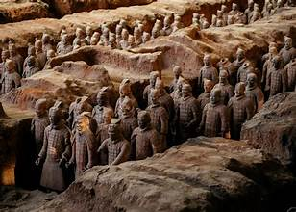

ARCHAEOLOGY

PRINCIPLES AND METHODS

Table of Contents

**Introduction** 3

**First instances of archaeology** 4

**Goals of Archaeology** 6

**Types of Archaeology 8**

**Historical Archaeology 9**

**Table: Difference between Traditional and New Archaeology 11**

**Types of sites 12**

**What is an Archaeological Survey?** 13

**Types of Archaeological Survey** 14

# **Introduction**

**Archaeology: definition and scope**

The essence of the archaeology is that it makes our world much more meaningful and resourceful. It depends our understanding of humanity and society. We sense the continuity of the human life when we confront with the material remains of the ancient civilization. The archaeological monuments stand as mute examples of the people who lived hundreds and thousands and thousands of years ago. The continuity of culture reminds us that people who lived hundreds and thousands of years ago. The continuity of culture reminds us that people have changed very little. Our aspirations, fear, and the concerns of our daily life are not so different from those of people who lived in earlier times – only the circumstances have changed. The life has become much more complex as a sequel to the advancement of science and technology. The past is not dead but it lives on with our customs. It is true that archaeology is not directly concerned with solving every problem society facing today, but it uplifts us by satisfying our basic desires and needs to know who we are.

## **First instances of archaeology**

**Excavations of Nabonidus (c. 550 BC)**

[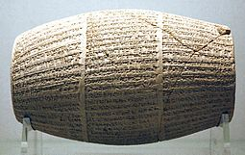](https://en.wikipedia.org/wiki/File:Nabonidus_cylinder_sippar_bm1.jpg)

[Nabonidus cylinder from Sippar](https://en.wikipedia.org/wiki/Cylinders_of_Nabonidus)

[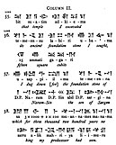](https://en.wikipedia.org/wiki/File:Nabonidus_cylinder_from_Sippar_(extract_about_Naram-Sin_and_Sargon).jpg)

Extract describing the excavation

[Cuneiform](https://en.wikipedia.org/wiki/Cuneiform) account of the excavation of a foundation deposit belonging to [Naram-Sin of Akkad](https://en.wikipedia.org/wiki/Naram-Sin_of_Akkad) (ruled c. 2200 BC), by king [Nabonidus](https://en.wikipedia.org/wiki/Nabonidus) (ruled c. 550 BC).

In [Ancient Mesopotamia](https://en.wikipedia.org/wiki/Mesopotamia), a foundation deposit of the [Akkadian Empire](https://en.wikipedia.org/wiki/Akkadian_Empire) ruler [Naram-Sin](https://en.wikipedia.org/wiki/Naram-Sin_of_Akkad) (ruled c. 2200 BC) was discovered and analyzed by king [Nabonidus](https://en.wikipedia.org/wiki/Nabonidus), c. 550 BC, who is thus known as the first archaeologist.[[12]](https://en.wikipedia.org/wiki/Archaeology#cite_note-RS-13)[[13]](https://en.wikipedia.org/wiki/Archaeology#cite_note-RLK-14)[[14]](https://en.wikipedia.org/wiki/Archaeology#cite_note-15) Not only did he lead the first excavations which were to find the foundation deposits of the temples of Samsa the sun god, the warrior goddess Annite (both located in [Sippar](https://en.wikipedia.org/wiki/Sippar)), and the sanctuary that Naram-Sin built to the moon god, located in [Harran](https://en.wikipedia.org/wiki/Harran), but he years, it was still a very good one considering the lack of accurate dating technology at the time.[[12]](https://en.wikipedia.org/wiki/Archaeology#cite_note-RS-13)[[15]](https://en.wikipedia.org/wiki/Archaeology#cite_note-hirst-16)[[13]](https://en.wikipedia.org/wiki/Archaeology#cite_note-RLK-14)

**First excavations**

**[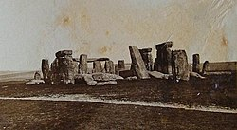](https://en.wikipedia.org/wiki/File:Stonehenge_1877.JPG)**

**An early photograph of**[**Stonehenge**](https://en.wikipedia.org/wiki/Stonehenge)**taken July 1877**[**Johann Joachim** [](https://en.wikipedia.org/wiki/File:Johann_Joachim_Winckelmann_(Raphael_Mengs_after_1755).jpg)**Winckelmann**](https://en.wikipedia.org/wiki/Johann_Joachim_Winckelmann)**(Raphael Mengs after 1755)**

of entire towns, complete with utensils and even human shapes, as well the unearthing of [frescos](https://en.wikipedia.org/wiki/Fresco), had a big impact throughout Europe.

However, prior to the development of modern techniques, excavations tended to be haphazard; the importance of concepts such as [stratification](https://en.wikipedia.org/wiki/Stratification_(archaeology)) and [context](https://en.wikipedia.org/wiki/Archaeological_context)

**were overlooked** One of the first sites to undergo archaeological excavation was [Stonehenge](https://en.wikipedia.org/wiki/Stonehenge) and other [megalithic](https://en.wikipedia.org/wiki/Megalith) monuments in England. [John Aubrey](https://en.wikipedia.org/wiki/John_Aubrey) (1626–1697) was a pioneer archaeologist who recorded numerous [megalithic](https://en.wikipedia.org/wiki/Megalith) and other [field monuments](https://en.wikipedia.org/wiki/Ancient_monument) in southern England. He was also ahead of his time in the analysis of his findings. He attempted to chart the chronological stylistic evolution of handwriting, medieval architecture, costume, and shield-shapes.[[31]](https://en.wikipedia.org/wiki/Archaeology#cite_note-32)

Excavations were also carried out by the Spanish military engineer [Roque Joaquín de Alcubierre](https://en.wikipedia.org/wiki/Roque_Joaqu%C3%ADn_de_Alcubierre) in the ancient towns of [Pompeii](https://en.wikipedia.org/wiki/Pompeii) and [Herculaneum](https://en.wikipedia.org/wiki/Herculaneum), both of which had been covered by ash during the [Eruption of Mount Vesuvius in AD 79](https://en.wikipedia.org/wiki/Eruption_of_Mount_Vesuvius_in_AD_79). These excavations began in 1748 in Pompeii, while in Herculaneum they began in 1738. The discovery**.**[**[32]**](https://en.wikipedia.org/wiki/Archaeology#cite_note-33)

### **Goals of Archaeology**

There are four basic goals of archaeology. These are listed below, with brief descriptions of each.

**1)** Recovery

, preservation, and description of remains

this includes but is not limited to sites, components of sites, features of sites, artifacts, types, varieties, attributes, geofacts, and Eco facts.

**2)** Reconstruction of past lifeways

**3)** Decipherment of culture history

there are multiple dimensions of archaeology. To properly understand culture history, at least two of the three major dimensions must be combined. The three dimensions, form, space, and time, can be related through diachronic studies (form over time) or synchronic studies (form over space). These are the most frequently, though not the only, methods used.

**4)** Reconstruction and study of cultural processes

this is the biggest goal of archaeology, and cannot be completed without previously completing some of the above goals. Often this is nearly impossible to do on a large scale; however that is still ideal.

#### Types of Archaeology

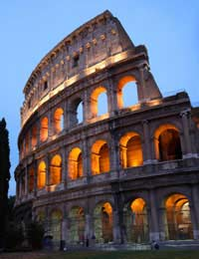

**The Variety of Archaeology**

The sheer variety that encompasses the rich subject of archaeology is often underestimated. Digging in the sand looking for the stone walls of a lost city, pulling on a wetsuit and diving into the dark oceans with SCUBA gear, or sitting for weeks with primitive Indians high on a lonely Peruvian plateau are all working types of the archaeologist.

**Classical Archaeology**

The examination of ancient Greek and Roman civilizations is known as classical archaeology. The two ancient cultures of Greece and Italy form the basis of classical investigation. The

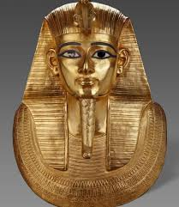Grecian Empire, the Roman

Empire and the trans between

the two, the Greco-Roman

Period, together permit a

2000-year era of Classical

history. The period between

around 500 BC to 300 BC

was known as the Classical

period or Golden age of Greece.

These short years have given us the great monuments, philosophy, art, literature and architecture that are now the building blocks of western civilization.

Certainly, the most famous sites of classical archaeology are found in Athens and Rome. Who can argue the grandeur of the Colosseum or the Parthenon? Yet classical archaeology is not confined to only the centers of these two great empires but even to the very extremities of their conquests.

##### Historical Archaeology

Historical archaeology pays great attention to the everyday world of all people. It is a conjunction of history and anthropology whereby the archaeologist seeks to understand the cultural processes and human experiences that produced the world we live in today through examination of the forms of writing and recording of information by past cultures.

Underwater Archaeology

Underwater archaeology employs special techniques to study shipwrecks and other submerged archaeological sites such as water-buried cities. Archaeologists who work under water rely on sophisticated diving and excavating equipment and employ special methods to preserve perishable materials that have been waterlogged for long periods.

Ethno-Archaeology

Artefacts such as weapons and tools along with human and animal fossils indicates that past cultures lived by hunting and gathering until relatively recently. A branch of archaeology has sought to understand these activities by studying today’s living groups of hunter-gatherers in Australia, Central Africa and even in the Arctic. Observing these living cultures in their natural environment and cautiously making deductions about the characteristics and behavior of their ancestors is a sub-domain of anthropology known as ethno-archaeology. Archaeologists believe that present-day hunter-gatherers such as the Australian Aborigine or the North American Eskimo, as well as people who lived during the Neolithic period share some aspects of each other’s ways of life.

###### **Table:** Difference between Traditional and New Archaeology

|  |  |  |  |
| --- | --- | --- | --- |
| **S. No** | **Method** | **Traditional Archaeology** | **New Archaeology** |
| **1.** | Nature: | It is descriptive in nature and data is being used to reconstruct the past | It is to explain the past based on the material evidence |
| **2.** | Explanation: | It is relying on historical explanation | It relies on cultural process |
| **3.** | Reasoning: | Traditional archaeologists | New archaeologists |

Types of sites

Each archaeological site, large or small, has its own distinct character and problems. Based on the availability of the cultural material they are identified as single or multicultural site. The single cultural site is generally occupied by a single group of people whereas the multi-cultural site is continuously occupied by over a given period of time. These sites are classified into Paleolithic, neolithic, chalcolithic, megalithic, early historic and historic sites and sacred sites with various sub-divisions. The following are some of the subdivisions:

* Prehistoric open area sites like riverside terraces such as Sohan valley river terraces.
* Prehistoric caves like Gudiyam and Bimbetka.
* Neolithic sites like ashmounds.
* Habitation mounds (also called *nattam, tells, tepe*).
* Habitation-cum-burial sites like Sanur, Kodumanal, Khapa, and Brahmagiri.
* Monumental sites like Harappa, Mohenjodaro, Kalibagan, Dholavira and Inamgaon.
* Sacred sites like Stonehenge, temple, stupa and church.
* Underwater sites (includes submerged ports and shipwrecks) like Dwarka, and Kaveripattinam.

**What is an Archaeological Survey?**

An archaeological survey is a systematic and large-scale examination of a designated land area to identify and document any archaeological resources present, such as historic structures, prehistoric artifacts, or buried features.

The objective of such surveys is always to preserve cultural heritage by identifying and protecting significant sites that could be disturbed or destroyed in various development or construction projects.

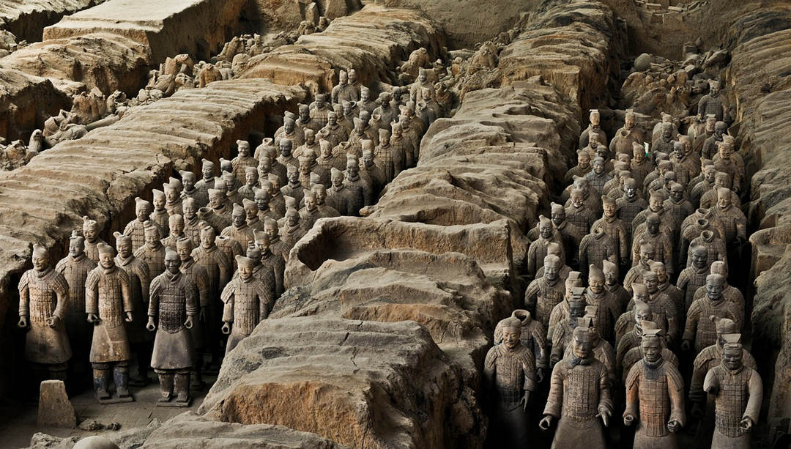

**Importance of Archaeological Survey**

It is also commonly conducted before any land development project, whether residential, commercial, or infrastructure.

In this regard, surveys of archaeological resources help in the decision-making process regarding what can and cannot be constructed on a site and what historical findings should not be dug up during development.

The absence of a proper survey exposes the development projects to unforeseen costs and delays, especially if significant archaeological remains are found during such constructions.

For this, the project might face major delays or the plans of the project would need to be changed at great costs. In addition, damaging heritage assets could also bring legal penalties and fines.

Besides, archaeological surveys play a significant role in planning. While reviewing planning applications, local planning authorities consider the impact of the development on heritage assets.

The findings of the survey, therefore, have a direct influence on how these impacts are managed to ensure that planning complies with preservation regulations and avoids any legal complications.

Documentation and protection of archaeological resources through surveys avoid both unexpected costs and the possibility of damaging historically important sites

**Types of Archaeological Survey**

Archaeological surveys can be classified by their methodology and scale into non-invasive versus intrusive surveys and extensive versus intensive surveys. Each kind is suited to different purposes and applies to different project needs.

**Non-Intrusive vs. Intrusive Surveys**

Non-intrusive surveys provide information regarding archaeological sites without disturbing the ground, preserving the sites for future generations.

These techniques of surface surveys, [aerial with drones or LiDAR](https://www.jouav.com/blog/lidar-drone.html), and geophysical ground-penetrating radar or magnetometry represent perfect options in the case of initial estimates or when the effective survey of vast areas is needed. This enables the identification of subsurface features and patterns without actual excavation.